Project: Form Engine

# Existing features:

Landing page:

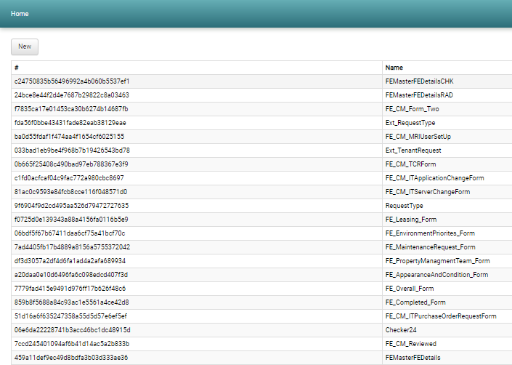

Form management page

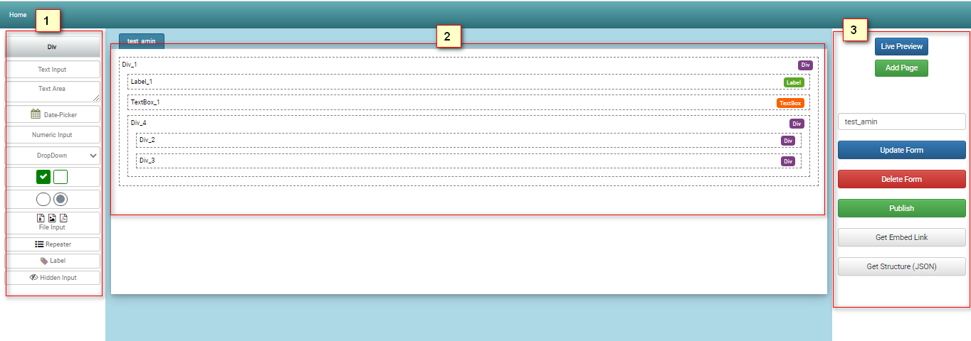

1. Section 1: Tools explorer
2. Section 2: Form management console
3. Section 3: Attributes

Live preview page:

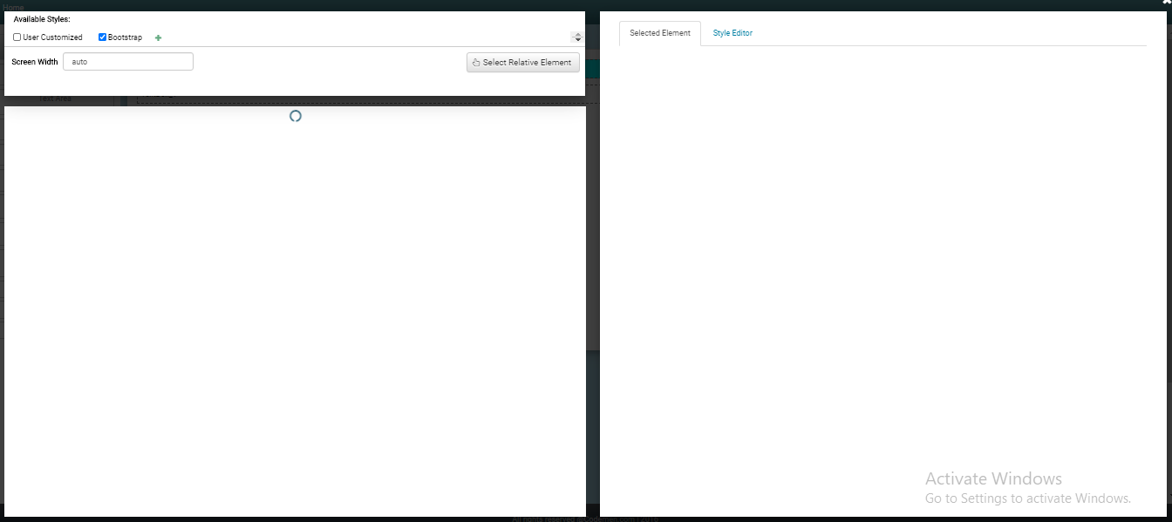

Video link (Must watch):

1. <https://drive.google.com/file/d/1gnA6L4i_Wmz5AySQ-HwzCTbJ4yU6FU21/view?usp=sharing>
2. <https://drive.google.com/file/d/1tJ7nl64isdYHgoAVPu-G-Zih4fP6eiXc/view?usp=sharing>
3. <https://drive.google.com/file/d/1SCdlXSXJ4eI3VeLB0jMCxccWT7WXgWbh/view?usp=sharing>
4. <https://drive.google.com/file/d/1hKyUMEK347emOiNN8vNc4azdfqRCPwa4/view?usp=sharing>

## Details of form engine:

**Introduction of Elements of Form Engine and its Functionalities**

|  |  |
| --- | --- |
| Div | Used for combining multiple elements in a section together as a bunch of elements. |
| Text Input | Used for receiving small text inputs such as Name, Country, etc. |
| Text Area | Used for receiving large text inputs such as Address, Summary, etc. |
| Date Picker | Used for selecting a particular date for occasions like birthdate, joining date, etc. |
| Numeric Input | Used for receiving only inputs which contains number such as Age, Mobile, etc. |
| Drop Down | Used for selecting a particular category among different categories such as CSE, BBA, EEE, etc. |
| Check Box Button | Used for presence or absence of multiple information such as Past Experience, Hobby, etc. |
| Radio Button | Used for determining particular information among few options such as Gender, Type of Student, etc. |
| File Input | Used for uploading a file as input to the server |
| Repeater | Used for storing multiple information of same category or type. |
| Label | Used for identification of a tab or button for future easy recognition. |
| Hidden Input | Used for password protection which means it remains unseen and can be seen for a while, if the button is clicked. |

**Elements of Form Engine and its properties**

1. Div:

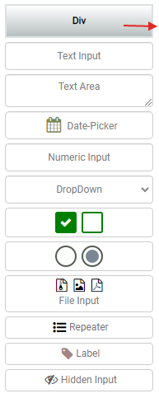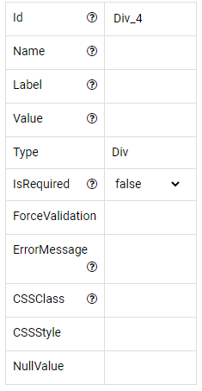

2.Text Input

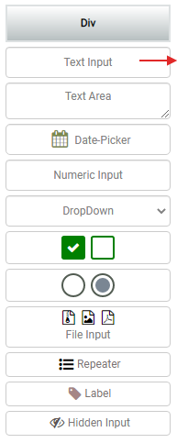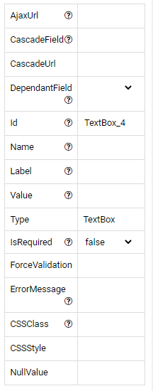

3. Text Area

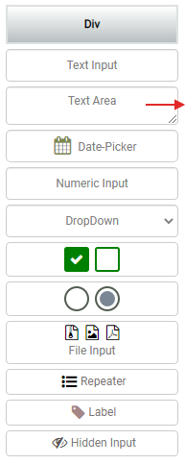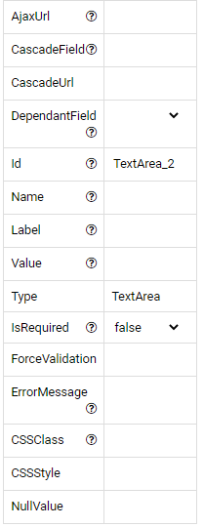

4. Date Picker

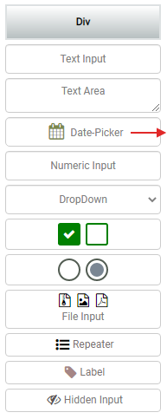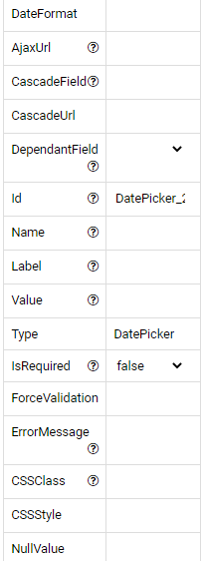

5. Numeric Input



6. Drop Down

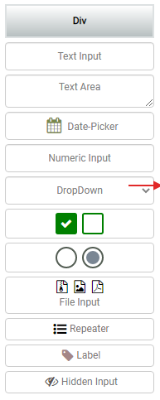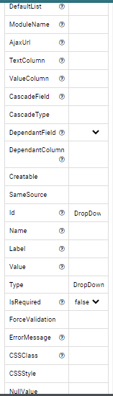

7. Check Box

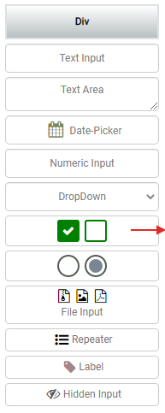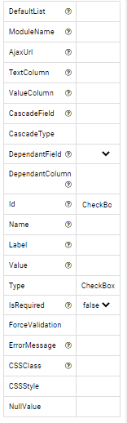

8. Radio Button

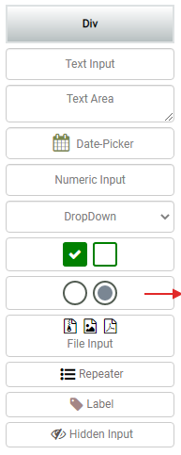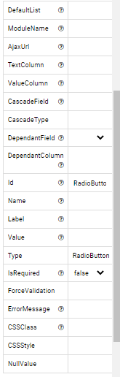

9. File Input

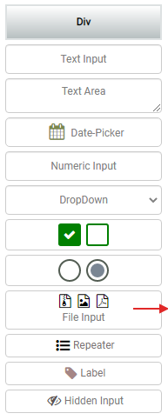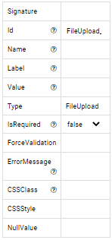

10. Repeater

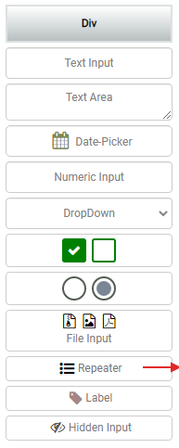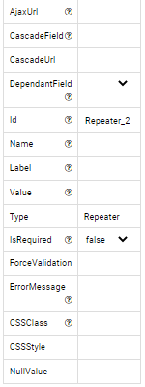

11. Label

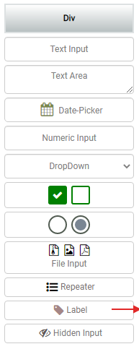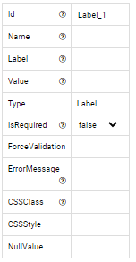

12. Hidden Input

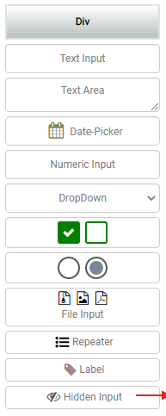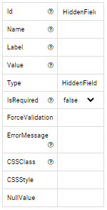

**Scope of work:**

**Design part:**

React Upgrade

Form should be handled by ID or a user defined unique key name

New interface Implement

Multiple Theme setting and output

New Controls: paragraphs, Headers (H1, H2…), auto complete, Image, map, signature, any missing standard elements

Condition in Control Implement a mechanism to apply condition in control for hide/show, cascade

CallBack function functionality to explore some callback function from forms

Offline data store

Multi Lingual Support

Validation (Client and Server)

Tooltip with example

Creating custom component (group of elements)

Duplicating entire form and edit

Design form from module using theme and predefined layout (eg: single row layout, double row layout, etc)

Giving a user friendly name, Categorization or sub categorization or folder / sub folder to organize forms, ability to search forms.

**Reusable Component**

React component to render a form passing the form ID

Offline data store

**Embed component**

Embed code for HTML

Embed code for React

Offline data store

**Project documentation**

Code documentation

User manual for admin and user